# Dashboard Insights

1.Key Performance Indicators

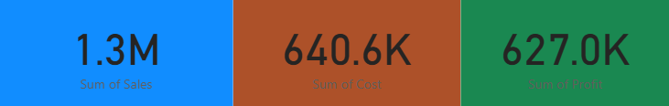

2.Map Chart(Sum of Sales By Country)

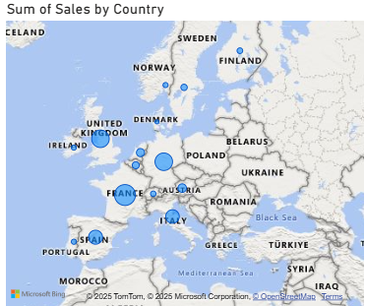

* Top sales are in Spain , France and UK

3. Table

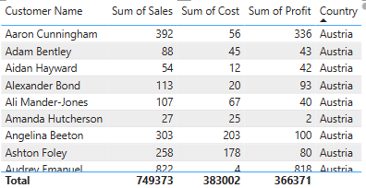

* Customer with highest sales is Alexander Bond
* Top performing countries are Spain,France and UK
* Customer with least sum of sale is Kristen Holland
* Least performing Country is Sweden
* Country with high profit is UK then France then Spain
* Country with least sum of Profit is Germany
* Country with large sum of cost is France then UK
* County with least sum of cost is Norway

4. Clustered Column Chart

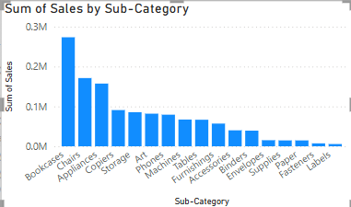

* Top performing 5 Sub-Category is
* Bookcases with sum of sales 273666
* Chairs with sum of sales 171275
* Appliances with sum of sales 157411
* Copiers with sum of sales 90897
* Storage with sum of sales 85587
* Least Performing Sub-Category is Labels

5.Pie Chart

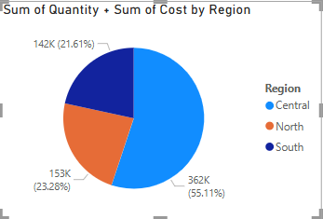

* Top region that contributing to the quantity sold with largest cost is Central with 55.11%
* Then comes North with 23.28% and South with 21.61%

6.Line Chart

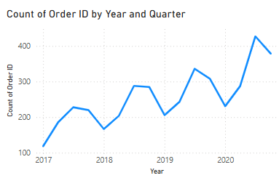

* larger number of Orders are in 2020 (Qtr 3) with count of order ID as 427
* Leat number of orders are in 2017 (Qtr 1) with count of order ID as 119